**Lab 2**

**Problem 1. Building an ER model from Database Schema**

1. Finding Entities, key Attributes and related Attributes

* Customers: customerId (PK), fullname(Middle Name and First Name), address, phone, birthday, sale, registrationDate
* Staff: staffId(PK), fullname(Middle Name and First Name), dayOfEntry, phone
* Products: productId(PK), productName, unit, nation, price
* Invoice: invoiceId(PK), purchaseDate, customerId(FK), staffId(FK), value
* DetailOfInvoice: invoiceId(PK)(FK), productId(PK)(FK), quantity

2. Finding Relationships

* Staff – Invoice: Handle
* Invoice – Product: Manage Sold Product

Identify the Cardinality

* Staff – Invoice: Many to Many
* Customers – Invoice: One to Many
* Invoice – Product: One to Many

3. Finding weak Entities and weak Relationships (if any):

* Weak Entity: DetailOfInvoice
* Weak Relationship: Invoice – Product

4. Draw an ER model

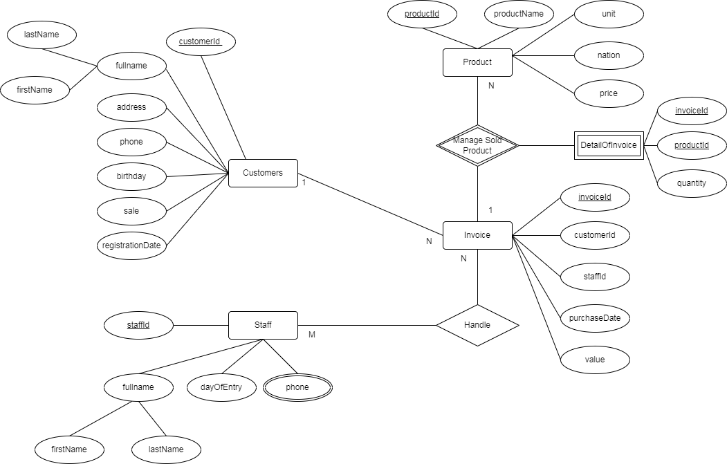

**Problem 2: Draw ER Diagram, then in change to Database Schema**

1. Finding Entities, key Attributes and related Attributes

* Industry Company
* Employee: Full Name(Middle Name and First Name), employeeCode(PK), dateOfBirth, address, gender, manager, department(FK)
* Salary: salaryCode(PK), employeeName (FK), department(FK), isPartTimeJob, workingHours, payRate
* Department: departmentCode(PK*),* roomName, manager(FK), startInChargeDate, location.
* Project: projectCode(PK), projectName, locationImplementation,

2. Finding Relationships

* Project - Department: managed by
* Project - Employee: joined by

Identify the Cardinality

* Employee – Salary: One to One
* Employee – Department: Many to One
* Employee – Project: One to Many
* Department – Project: One to Many

3. Finding weak Entities and weak Relationships (if any):

* Weak Entity:
* Weak Relationship:

4. Draw an ER model

